14.73: a) See Exercise 14.23; the fraction of the volume that remains unsubmerged is 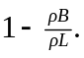 b) Let the depth of the liquid be x and the depth of the water be y. Then Therefore 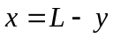 and 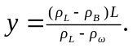 c) 